Phonics Teaching Policy

Contents
1. Subject Statement
2. Teaching and Learning
3. Assessment:
4. Planning and Resources
5. Organisation
6. Equal Opportunities
7. Inclusion
8.Role of the Subject Leader
9.Parents

Subject Statement
Intent
At Sabden Primary School, we strive to teach children to read effectively and quickly using the Red Rose Letters and Sounds scheme which includes teaching synthetic phonics, sight vocabulary, decoding and encoding words as well as spelling and accurate letter formation.
Using Red Rose Letters and Sounds we teach children to decode and then read. We aim to teach children from Early Years up to Year 2 to:
● apply their phonic knowledge and skills as the route to decode words
● respond speedily with the correct sound to graphemes (letters or groups of letters) for all common 40+ phonemes
● read accurately by blending sounds in unfamiliar words that contain the Grapheme Phoneme Correspondences (GPCs) that they have been taught
● read common exception words, noting unusual correspondences between spelling and sound
● read words containing taught GPCs and –s, –es, –ing, –ed, –er and –est endings
● read words of more than one syllable that contain taught GPCs
● read words with contractions and understand that the apostrophe represents the omitted letter(s)
● accurately read aloud books, that are consistent with their developing phonic knowledge and that do not require them to use other strategies to work out words
● re-read books to build up their fluency, accuracy and expression and hence develop confidence and enjoyment of reading
● read most high-frequency regular words quickly and accurately, without overt sounding and blending; only needing to sound out unfamiliar words
● spell words containing each of the 40+ phonemes by segmenting the sounds in words
● spell common exception words correctly
● add prefixes and suffixes to previously taught words
● spell effortlessly, and with confidence, so that all their focus when writing can be directed towards composition
● make phonetically plausible attempts to spell words correctly
● select the correct GPC for words that contain sounds that have more than one GPC – e.g. ay, ai, a-e etc.
● form each letter correctly, using pre-cursive letter formation rhymes to encourage correct entry and exit points, orientation and letter size.

At Sabden Primary School, these skills are embedded within daily phonics lessons. By focussing on the teaching of reading in the Early Years and KS1, following the letters and sounds phonics plan, children learn to read unfamiliar printed words by blending (decoding) and speedily recognise familiar printed words by sight. We want all children to enjoy and experience early success in learning to read. We are committed to developing children’s love of reading and to help them to acquire knowledge and to build on what they already know.
Implementation
These principles and features characterise our approach to the teaching of reading using phonics:
● Teachers teach phonics using a detailed, proven step-by-step teaching plan; where children are first taught simple GPCs, to accurately blend taught sounds, to decode simple words containing taught graphemes and then to read books that are closely matched to their increasing knowledge of phonics and the common exception words.
● Pupils are taught within small groups, across year groups, which reflect their performance in phonics assessments. We make sure that pupils read books that are closely matched to their increasing knowledge of phonics and ability to read ‘tricky words’; so they experience early reading success and gain confidence that they are readers.
● Phonics teachers have all the resources needed to teach their phonics sessions and they follow detailed lesson plans. This ensures the consistency of the teaching of phonics and early reading, in every lesson, irrespective of the teacher.
● Teachers attend regular in-house CPD sessions, where they have the opportunity to learn about pedagogical changes, new resources and to observe and practice specific parts of the teaching process.
● Regular assessment ensures that pupils are taught in suitable groups which match their phonic knowledge and reading level. Pupils making speedy progress move groups quickly. Those pupils making steady progress continue at an appropriate pace matched to their reading level. Those pupils making slower progress are usually taught in smaller groups and generally receive additional small group or one-to-one intervention.

Impact
We assess all pupils from Reception to Year 2 using the same assessment materials each half term. We use this data to assign them to their correct phonics Group and to identify if they need to have any additional support. This provides a good indication of their progress relative to their starting points. We track the phonic progress that pupils make from Reception to Year 2 and, at the end of Year 1; we evaluate pupils’ acquisition of GPCs and decoding skills using the Phonics Screening Check (PSC).
This ensures that we are able to maintain high standards in the teaching of the early stages reading in EYFS (using the Reading statements in the EYFS Profile), in Year 1 (using the PSC materials) and in Year 2 (using the statutory KS1 Reading assessment materials). Pupils in KS2 that are still acquiring word reading skills, continue to be part of the phonics teaching program, however this would be delivered in such a way that is suited to their age group.
The impact of high-qualify synthetic phonics teaching, coupled with vigorous assessment procedures ensures that attainment of Sabden Primary School pupils is above that of the Lancashire and National Standards.

Teaching and Learning
Children in nursery are exposed to phase 1 phonics, focussing on:
- Environmental sounds.
- Instrumental sounds.
- Body percussion (e.g. clapping and stamping)
- Rhythm and rhyme.
- Alliteration.
- Voice sounds.
- Oral blending and segmenting (e.g. hearing that d-o-g makes 'dog') lessons start during the spring term.
Towards the end of nursery and start of reception, children begin to have short phonics input session, where they are taught two new Phase 2 sounds per week and they also review previously taught sounds every day. Pupils practice segmenting and blending, to develop decoding skills, and they learn to write the corresponding graphemes for the sounds they have been taught.
Children also write simple CVC words, using their GPC knowledge to assist them. Towards the end of the summer term, there is an increase phonics focus during daily literacy lessons where children are encouraged to hear and write the initial and final sounds in words.

Reception Phonics lessons start immediately after they have completed their Baseline Assessment. Children are organised into groups based on their phonic knowledge, ability to orally blend taught phonemes and read simple CVC words. This ensures the correct level of support, challenge and progression in the teaching of reading in Reception. Phonics is taught daily each week and each lesson lasts for approximately 30 minutes.
Daily KS1 phonics lessons commence at the start of the academic year; children are grouped by their phonic knowledge as well as their reading accuracy, fluency and comprehension. Daily phonics lessons are taught every week and each lesson lasts for approximately 30 minutes.
Phonics sessions follow the sequence below in each phase.
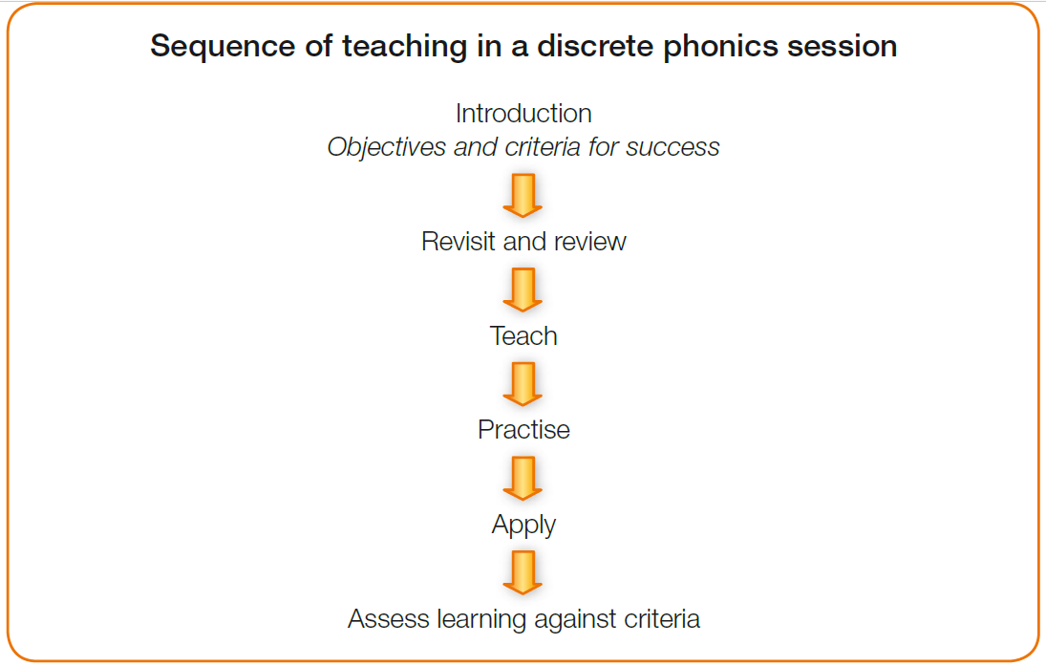
The aim of the phonics session is introduced to the children at the start of the session. Then in ‘revisit and review’ new sounds are taught, or previously taught sounds are reviewed.
In ‘teach’ children are introduced to a new sound.
In ‘practice’ they learn how to apply their grapheme/phoneme knowledge to read real simple words – initially sounding out these words and then progressing onto speedy reading of words – and also alien (pseudo) words. They also learn how to read irregular words and multisyllabic words.
In ‘apply’ teachers may choose a wide range of strategies to allow the children to use the new sound they have learnt, whilst consolidating previously taught correspondences.
By the end of the session, staff ‘assess’ the children’s knowledge through the previous steps and plan accordingly for the following session.

Assessment
Assessment for Learning:
Assessment is a critical element of our phonics teaching. The teachers assess:
- pupils’ phonic knowledge
- the speed at which pupils are able to read words
- pupils’ application of blending and segmenting

Formative Assessment:
Daily formative assessment opportunities are built into every phonics lesson. Choral response group work, partner work, the small class size allows teachers to evaluate pupils’ phonic knowledge and hence modify the pace and focus of their lessons. Formative assessment opportunities provide teachers with knowledge of which children are making slow, steady or speedy progress and hence they can liaise with the Reading Leader to provide additional support (for children making slower progress) or an immediate assessment (for pupils making speedy progress) to allow such pupils to change group.

Summative Assessment:
All pupils are assessed every half term or more frequently for those making speedier progress, using phonics assessment materials. The assessment is conducted by the phonics group teacher and the materials assess a pupils’ sound to grapheme correspondence, ability to apply phonic knowledge to decode regular words and to read common exception words. Pupils reading fluency is also evaluated. Pupils’ progress is tracked, to record their phonic knowledge and decoding skills, and this information is used to reorganise groups and the focus of the phonics input of the lesson.
Summative assessment is used to update phonics tracking sheets, which monitors pupils’ progress over time, and also to update assessment grids. Assessment information, from both the formative and summative assessment progresses, is used to provide updates to parents via Parents’ Evening updates or more specific meetings with parents.

Planning and Resources
Planning is minimised as we follow the Red Rose Letters and sounds scheme and plans. This ensures consistency across the program, as well as freeing up time for teachers to source additional resources etc. to make the lesson come alive to the class.
Planning details the focus of each part of the phonics lesson and explains the purpose of the activity to both the teacher and the pupil. Planning also explains the resources needed for each day in a 5-day teaching cycle.
Every phonics teacher has their own box of phonics resources these include :
- Small and large phonics flash cards,
- Phonics order of teaching
- Phonics books correspondence lists
- High Frequency words and Common Exception Words

Organisation
Teachers follow Sabden Primary School phonics lesson plans and ensure that the lessons are taught at a good pace to ensure that all children are engaged and involved in the lesson. Children are praised for their contribution to lessons, reading and effort so that a very positive and respectful teaching environment is maintained.
Every part of the lesson is explicitly referred to so that the teachers, and the children, know the purpose of the task. Use of effective partner work, turn-taking and children taking on the ‘teacher role’, means that children have an active role in all parts of the lesson. We teach pupils to work effectively with a partner to explain and consolidate what they are learning. This provides the teacher with opportunities to assess learning and to pick up on difficulties, such as pupils’ poor articulation, or problems with blending or alphabetic code knowledge. Teachers demonstrate their enthusiasm and passion for phonics and reading and this has a very positive impact on the teaching and learning environment.

Equal Opportunities
At Sabden Primary School Primary school, we are committed to providing a teaching environment which ensures all children are provided with the same learning opportunities regardless of social class, gender, culture, race and disability or learning difficulties. The school works to ensure the active participation and progress of all children in their learning.
All children will be given equal opportunities to achieve their best possible standard, whatever their current attainment and irrespective of gender, ethnic, social or cultural background, home language or any other aspect that could affect their participation or the progress of which they are capable.

Inclusion
All pupils are entitled to access phonics resources and teachings at a level appropriate to their needs arising from race, gender, ability or disability. A range of inclusion strategies, as listed on the school’s inclusion planning key, are embedded in practice and teachers are aware of the special educational needs of the children in their phonics group, as well as those who have English as an additional language.
The 2014 National Curriculum states that:
‘Pupils who grasp concepts rapidly should be challenged through being offered rich and sophisticated problems before any acceleration through new content. Those who are not sufficiently fluent with earlier material should consolidate their understanding, including through additional practice, before moving on.’
Pupils making accelerated progress will move groups to ensure that an appropriate level of challenge is provided. Pupils that need additional support to consolidate their phonic knowledge and its application will generally be taught in smaller groups where they have the opportunity to consolidate their knowledge prior to moving onto the next stage. If appropriate, further intervention will be provided to support their phonic development. Specific arrangements for the provision of children with SEND will be communicated to parents and carers during SEND reviews.

Role of the Subject Leader
The Early Reader and Phonics Subject Leader:
● Oversees the assessment of all Reception & Key Stage 1 pupils, reviews assessment data to organise pupils to the correct phonics groups.
● Provides phonics teachers with a list of graphemes that their group requires consolidation of
● Assigns phonics teachers to phonics groups
● ‘Drops in’ on phonics groups to give advice and to informally check that pupils are in the correct groups through learning walks and scrutiny of work
● Where necessary, models lessons, team-teaches and coaches existing and new staff.
● Ensures that all staff are trained in phonics
● Strives to not have her own reading group but covers for staff absence, assesses, models and coaches phonics teachers where necessary.
● Liaises with the Head Teacher regarding groupings, teaching spaces, staffing, training, progress, additional support and other relevant matters
● Is responsible for reporting to the governors about the quality of the implementation of phonics and the impact on standards
● Meets with the EYFS and KS1 team every half term to review progress.

Parents
In Nursery and Reception, whilst children are learning the Phase 2 and 3 sounds at school, children will have the opportunity of practising the speed sounds that they have learned at school with their parents/carers.
Reading will be sent home so that children can read these books to their parents that follow the level of phonics teaching the child is at. These will be allocated by the phonics teacher every 2/3 days. This is because each read through of the book focusses on specific skills; decoding, reading with expression, accuracy and fluency as well as reading for comprehension. We also send home a list of irregular ‘tricky’ words that need to be known by sight and cannot be decoded using common graphemes.
We provide parents with children in Nursery, Reception Year 1 with information to show how parents can support their children to read at home, depending on which stage of the phonics program they are on. We also provide information about the Phonics Screening Check for Year 1 parents, during the spring term, to help parents understand the PSC and suggest ways to best support their child at home. We encourage parents to help their child learn to read.
Reviewed Summer 2023.
To be reviewed in Summer 2025.

